26-2-11 Trade Like a Professional, Not a Gambler
## 1 BTC 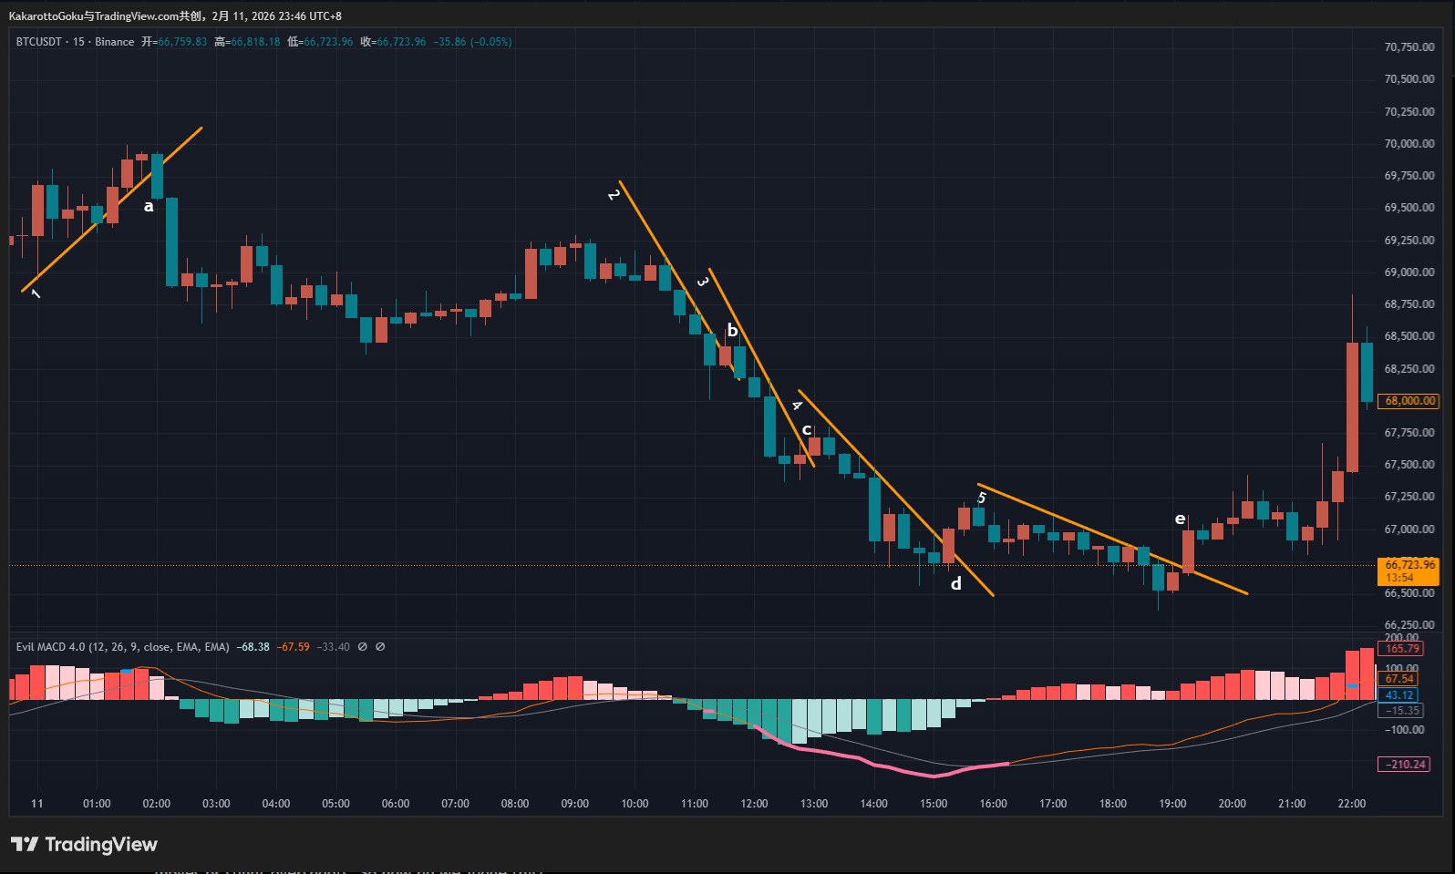 First, we can see a blue warning line, indicating a potential top. The price action formed Trendline 1. Notice that in the middle of Trendline 1, it was briefly broken by one bearish candle and one bullish candle. Some traders may argue that this invalidates the trendline.
However, in live trading, we rarely get perfect textbook setups. We often encounter sudden moves or slight overshoots. So how do we judge this?
A trendline is essentially a representation of short-term consensus. As long as that consensus remains, the trendline remains valid. When consensus disappears, the line naturally breaks. In essence, it reflects short-term market agreement.
Looking at this minor breach of Trendline 1, the bearish candle closed right at the trendline, and the following bullish candle did not have a long lower wick—it rebounded upward quite cleanly. Therefore, this did not constitute a true break of the trendline. (Real trendline breaks do occur in live trading—we will discuss them when we encounter one.)
Later, at point a, the trendline was broken decisively by a strong bearish candle with a solid body. This was a clean downward breakout and confirmed a structure shift from bullish to bearish.
Subsequent price action shows that when you align with market momentum at the correct structural point, the market often provides significant profit potential.
After that, the price action became more complex. The pink bottom warning line lasted for quite some time, so let’s break it down step by step.

Trendline 2
This trendline was clean, unbroken, and validated by the market. It was broken upward at point b.
However, observe candle b carefully: small body, upper wick almost equal to the body, and the close was very close to the trendline. This was not a decisive breakout. In other words, we could not see strong bullish momentum. Therefore, this opportunity should be skipped.

Trendline 3
After point b, the market reversed again and formed Trendline 3. There were two doji candles at the bottom—many traders would attempt to buy the dip here.
But don’t rush. Just because many people think this way doesn’t mean it’s correct.
At point c, price broke upward. However, the issue at c is the same as at b: small body candle, upper wick nearly equal to the body. Although the breakout was slightly stronger than at b, we still couldn’t see clear bullish dominance. So this opportunity should also be avoided.
(In Japanese Candlestick Charting Techniques, doji candles are considered reversal signals. This view is somewhat outdated given the era in which the book was written. In live trading, we should be more flexible. Classic theories are useful for understanding principles, but should serve only as references.)

Trendline 4
After the failed breakout at c, a new trend formed. This trendline was validated by the market and considered qualified.
At point d, price broke upward. This met the conditions for entry, but it wasn’t an ideal setup. Although the breakout candle had a solid body, its momentum did not show clear dominance compared to nearby bearish candles.
Our method focuses on identifying where collective market force shifts direction, so visible momentum is critical. At d, momentum was slightly weaker than nearby bearish candles.
Therefore, whether to enter depends on personal risk tolerance. Aggressive traders may enter; conservative traders may wait. There is no absolute right or wrong.

Trendline 5
After the breakout at d, price reversed downward again. But this time, we could clearly see bearish exhaustion in the candlestick structure.
Trendline 5 formed and was broken upward at point e. Comparing d and e, the momentum at e was clearly stronger. A simple way to judge: at d, bullish strength was weaker than nearby bearish candles; at e, bullish strength was clearly dominant.
Thus, e was the optimal structural shift point.

2 ETH
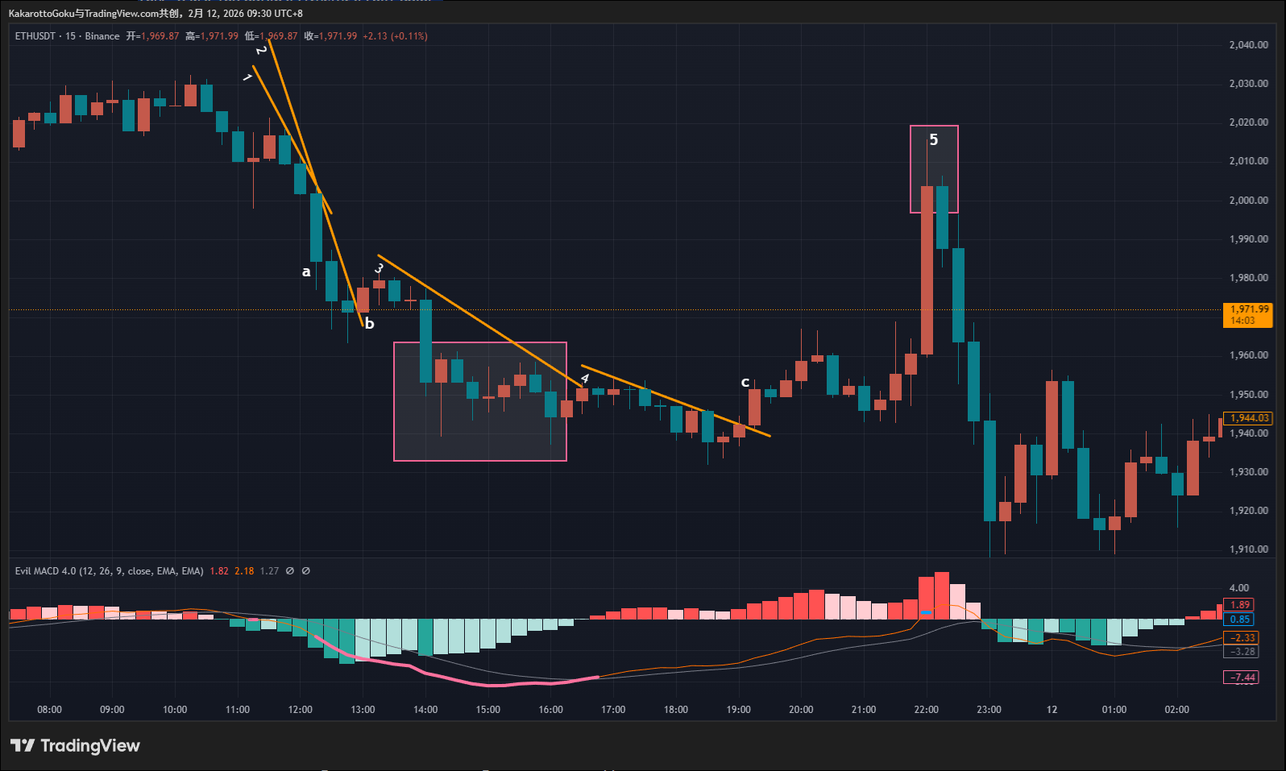 For a long period, there were no reversal warning signals. In such conditions, you should not attempt to enter, because markets without reversal signals are often just ranging.
Later, a bottom reversal signal appeared near Trendline 1. However, Trendline 1 was never broken upward. Instead, price accelerated downward at point a.
From a to b, some traders may mistakenly draw Trendline 2. But after a, price never touched that line again. According to my criteria, Trendline 2 is invalid.
Trendline 3 is also misleading. There was a bottom signal and the line appeared validated at first glance. But price was not truly constrained by it—a large bearish candle shifted the structure significantly. The movement resembled a triangle.
In my view, Trendline 3 was not clean enough, so I would skip it.
Eventually, Trendline 4 formed. It was properly validated, without sudden acceleration like Trendline 1, and without triangle-like structure as in Trendline 3.
At point c, price broke upward with a strong-bodied bullish candle, minimal wicks, and momentum stronger than all nearby bearish candles. This was a standard bearish-to-bullish structural shift.
Later, there was a small topping signal near point 5. However, price moved too quickly to form a clear trendline, so this opportunity should also be avoided.

3 Gold
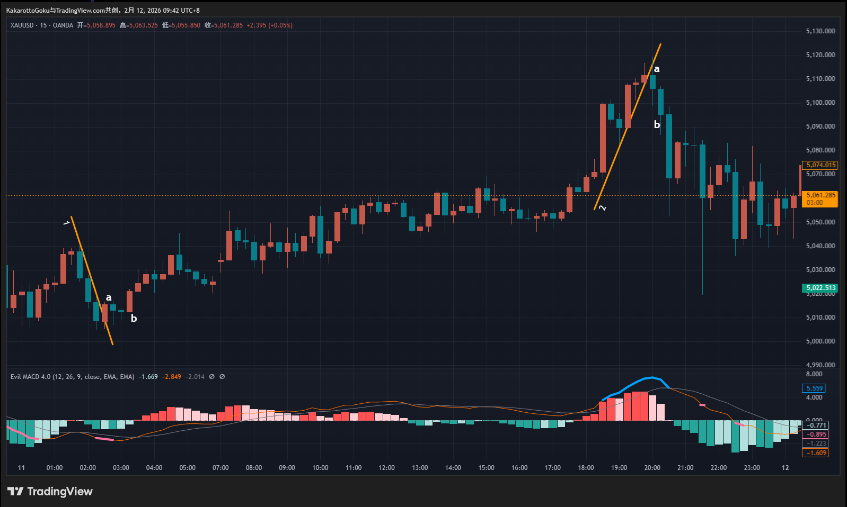 Today’s gold chart is highly valuable for review and learning. It involves both understanding trendlines and a common mistake many traders make during review.
First, we can clearly see a pink signal and the formation of Trendline 1. It was broken upward at point a.
Different traders may interpret this differently. Aggressive traders may consider this a valid breakout, as the candle body dominates and signals a bullish shift. Conservative traders may argue that the body at a is slightly smaller than the previous bearish candle, so bullish dominance is not yet confirmed.
Neither view is right or wrong—it depends on risk preference and trading style. As long as your logic is consistent with your system, it is valid.
After a, two small bearish candles formed. Their bodies shrank progressively and their lows rose gradually. This clearly shows bearish momentum exhaustion.
Then at point b, price surged upward, breaking above a and the two small bearish candles. No matter your approach, b can be considered a confirmed bearish-to-bullish shift.
If the certainty at a was 50%, then b was at least 90%.
What we should really focus on is the later top warning.
We can barely draw Trendline 2, but from previous analysis, we notice repeated upward jumps away from the line, forming choppy oscillations.
This volatility was almost certainly caused by upcoming major economic data.
Here lies a common mistake.
Many people try to predict major announcements or meetings beforehand to gain attention or prove themselves. But markets during such events are highly random and uncertain.
Can we predict whether Powell will say “Good afternoon” or “Hello everyone”? Of course not.
Before major data releases, many traders like to guess direction. But this behavior is no different from gambling. The volatility is large—if you guess correctly, rewards are big. But if wrong, you may blow up your account.
Even if you are right once, can you guarantee being right every time? One mistake could be catastrophic.
In options markets, there is a key metric called implied volatility. Before major announcements, implied volatility rises sharply, pushing option prices higher—both calls and puts become more expensive.
It is usually better to stay flat during such periods because once the data is released, implied volatility drops sharply. You would have paid an inflated premium for anticipated volatility. That is inefficient.
Although this is not the options market, the logic still applies.
New data and meeting outcomes are unpredictable. This is the kind of random, high-volatility environment that gamblers love.
As disciplined traders, we should avoid such areas. Nine out of ten times, gambling loses.
Looking at the chart, Trendline 2 was broken downward at a, but notice that this candle had a small body and very long wicks—the combined upper and lower shadows were more than twice the body. This indicates intense struggle between bulls and bears.
Although b was another bearish candle, it also had a long lower wick and was very close to Non-Farm Payroll release time, meaning massive volatility could occur at any moment.
In such an environment, I personally prefer to stay out.
Many people like to give predictions before data releases. But to me, this type of market is closer to randomness, and I prefer not to participate.
I am offering this advice from the perspective of a conservative professional trader.
Which approach is better? With experience, you will naturally understand.

